Day 13

Take up Test

Unit 2 - Energy and Rates Intro

Demo Endo/Exo

Objectives, “We’re #1” handout

Work through overheads (need to be photocopied)

HW R&MN 5.1 P 1-4,7(you tell me),8-16
Q 1,2

5.2 P 1-5,9,10 2 days
Q 1-5
  - P 1-5
Handout – calorimetry (tough)
Day 14
Overheads – specific heat capacity, calorimetry

Writing Thermochemical Equations
ENDOTHERMIC
2X + Y + 50kJ → Z
2X + Y → Z ΔH = +50 kJ
2X + y → Z ΔH = +50kJ/mol Y or ΔH=+50kJ/mol Z or ΔH=+25kJ/mol X

EXOTHERMIC
A + 2B → C + 75kJ
A + 2B → C ΔH=-75kJ
A + 2B → C ΔH=-75kJ/mol A or ΔH=–37.5kJ/mol B or ΔH=–75kJ/mol C

Prep combustion lab (purpose to blank observation table before class) – handout

Finish yesterday’s work

lots of equipment Day 15
ICE - lots

ISQ2 tomorrow

Combustion lab

Hand in -Abstract
-calculation #4
Q 2,3
Conclusion – Number plus % error

Day 16

Talk about lab

ISQ2

State properties/Hess’s law notes on overhead

R&MN 5.4 P 1-5
Hess law handout
Day 17

Pick up lab – mark in class

Abstract /2 past tense, reactions
Observations /2
Calc#3 /1
Calc #4 /1
Q #2 /2
Q #3 /2 incomplete rxn, loss of heat to environment
Conclusion /1 should be ΔHc with % error (1 mark for error calc)

Calc#4 – 13360 * 100%
13360
PENALTIES -1 each

Impression /3
Discussion /3

Total /17-penalties

Prep heat of combustion of Mg (full write up) – pg 351
Must have Hess’s law calc done as pre-lab!

Notes on Standard Enthalpies of Formation

HW R&MN 5.5 P 1-3,5,7,10
Q 2-4
Assignment
lots of equipment Day 18

Mg lab pg 351

Hand out ASS’T due day 23
Day 19

Day 20

Talk about lab

Nuclear handouts

If extra time they can have part of a period as a work period

HW R&MN 5.6
Molecular models Day 21

Day 22

Day 23

IS periods/IS test 1

21 – IS labs – models/WP - give them number of structures

22 – IS work period – take up models lab in class – not marked

23 – IS Test 1 – 35 min – take up in class
KClO₄ demo Day 24

Ass’t due and take up in class

Rates Intro

Demo

Objectives

Intro handouts/overheads

HW R&MN 6.1 P 1,2 pg 361
P 1,2,4-9 pg 364
Q 1,2

Day 25

factors affecting rate – demos – just lichopodium

HW Use the three microscopic factors to explain the five macroscopic factors. (for next day)

R&MN 6.3 P1-8 memorize half life eq’n or use the old half life eq’n
Q1-6
6.4 P1,2
Q1-3
6.5 P1,2,4,5,9 memorize Arrehenius eq’n
Q1-3
Hand out assignment – due day – mark in class

Intro theoretical lab

Talk about theoretical lab – straight line is direct relationship so plot rate vs. [ ], rate vs. [ ]² and rate vs. [ ]³ etc. to see which is straight.

Factors Affecting Rate of Reaction
(Macroscopic)

Nature of Reactants - (demo Li, Na, K)
In general, reactions between simple ions (Ag⁺, Fe⁺²) are faster than reactions between complex ions (C₂O₄⁻², Cr₂O₇⁻²).

Moreover, for all types of reactions the rate of two similar reactions depends o the nature of the reactants.

Eg] Li vs. K in water or eg] H₂ +Cl₂ → explosive with light
H₂ + O₂ → stable with light, explodes
with spark

Concentration of Reactants – Demo from yesterday – burning in air (20%O₂ vs. 100% O₂)
Or Mg with 6M, 3M, 1M HCl & balloon to capture H₂

The reaction rate increases as the concentration of the reactants increases.
What does this mean about rate as reaction proceeds?
Rate decreases as reaction proceeds due to the consumption or reactants.

Temperature of Reaction – Demo hot HCl with Na₂CO₃ vs. cold HCl with Na₂CO₃
OR talk about Fridge, near drownings in cold water

Reactions occur faster at higher temp and vice versa.
Eg] refrigerator, near drownings in cold water

In general a 10ºC rise in temperature doubles rate.
Catalysts – what is a catalyst?

A catalyst Is a reagent that increases or decreases the rate of reaction but is not consumed in the reaction. They often provide a surface to react on or a lower Ea pathway for the reaction

Eg] beer pop bubbles
Eg] H₂O₂ 2H₂O + O₂ slow
MnO₂
H₂O₂ 2H₂O + O₂ fast

Eg] in biology, catalysts are called enzymes. Ever heard of lactose intolerance?
Your body has many enzymes that slow down reaction – think burning gummy bear.

Surface Area – how do we increase surface area?
Increasing the surface area of the solid increases the rate
of reaction because more reactants are in contact (Just like increasing conc.)
Eg] mossy zinc vs zinc powder
Eg] start a fire with logs? Or kindling
Eg] lichopodium
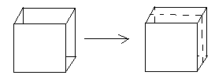Go through productive worker analogy.

Take up theoretical lab

How do reactions come about? What must happen? Imagine Mr. Sleeman and Mr. Deacon in velcro suits walking around an empty gym. They have the potential to stick but do not. Why?

Collision Theory of Reaction Rates
Review KMT
Model – particles of reaction mixture are in constant random motion
- particles must collide in order for a reaction to occur. BUT not every collision is successful.
Why wouldn’t a reaction be successful?

The three microscopic factors that affect rate are: Drag this out of them…

Geometry – the particles must collide with the correct orientation for a reaction to occur. In larger molecules there may be only one reaction site where a reaction can take place so the geometry of collision must be very specific or no reaction will occur.
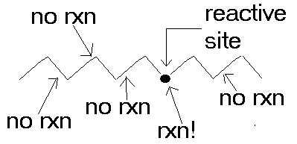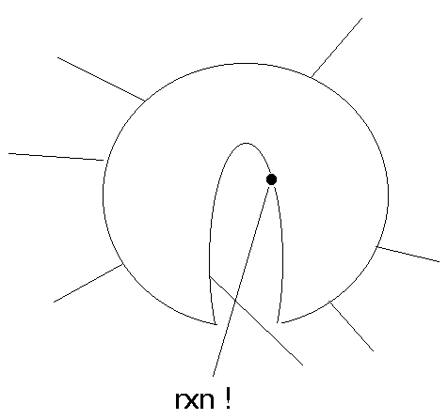
Eg] Eg] enzymes
Imagine lobbing a water balloon against a wall:
If you throw it softly what happens?
If you throw it harder what happens? Why?
Imagine H₂ and O₂ molecules colliding softly. What happens? If they move faster what happens? Why? BDE !!
How do we increase speed of movement? Temp

Activation Energy (Ea) – the minimum amount of kinetic energy of collison necessary to break the chemical bonds of reactants allowing reaction to occur.
Using our energy diagrams developed for endo and exthermic reactions we can now include Ea

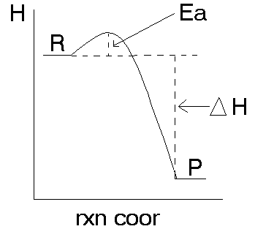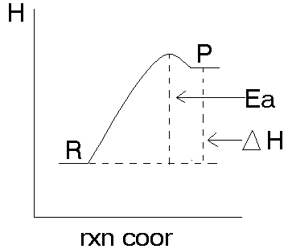 Exothermic Endothermic
Why are there so few endothermic reactions? Huge Ea
When reaction temp increases 10ºC the rate usually doubles. Why?

Handout & overhead – kinetic energy distribution graphs

At higher temperature more particles have the required activation energy so the rate is faster. NOTE: the Ea does not change but the number of particles above that Ea increases.

Number of Collisions – given A + B → AB
Eg]
A
A
A
A
A
A

B
B
B
B
B
B

As we increase the number of reactant particles the number of collisions increases so even if the % of successful collisions stays the same, the rate increases.

Rate α [A][B] so [A] then rate [B] then rate

[A] then rate [B] then rate

Rate Determining Step demos Day 26
talk about theoretical lab Take up – Use 3 micro to explain 5 macro
ISQ3 soon

Energy diagrams
Given NO + O₃ → NO₂ + O₂ NH₄Cl + H₂O → NH₄⁺ + Cl⁻

H R What’s H P
here?

P R

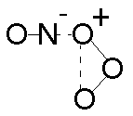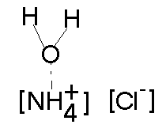 Rxn coor Rxn coor

The Activated Complex – (the bat- ball)
The activated complex is a short lived, high energy, unstable intermediate formed during a reaction. This state exists for microseconds when the bonds in the reactants are weakening and the bonds in the product are beginning to form. This state can now be viewed with “flash spestroscopy” – nanosecond lasers.

Forward vs. Reverse Reactions
If the forward reaction is exothermic ΔH=-250kJ then the reverse reaction is endothermic ΔH=+250kJ.

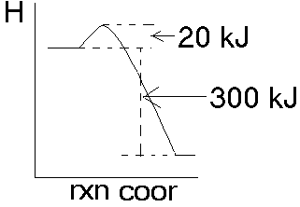If the forward reaction is exothermic ΔH=-300kJ with an Ea=+20kJ then the reverse reaction is endothermic with an Ea=+320kj and ΔH=+300kJ.
If the forward reaction is endothermic, ΔH=+40kJ, with and Ea=+100kJ then the reverse reaction is exothermic, ΔH=-40 kJ and Ea=60kJ

The Effect of Catalysts on Activation Energy
Catalysts can affect rate by many means and often the exact method is unknown (but they work so they are used widely)
- Provide a surface eg] pop or catalysed H₂ production
- 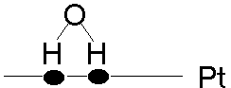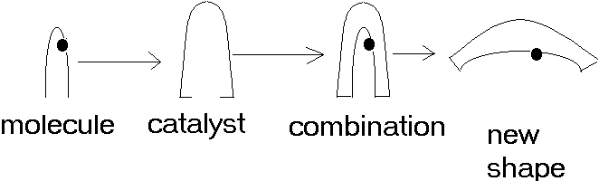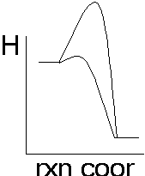Geometry – can open up a reaction site

- Provide a low Ea pathway (or higher Ea to slow rxn). The catalyst itself becomes part of the activated complex but at a lower energy.
Huge $$$ in industry – think of lowering energy cost or speeding up rxn=more$ faster.
Reaction Mechanism
Eg] C₃H₈ + 5O₂ → 3CO₂ + 4H₂O What does this reaction mean?
1 propane + 5 oxygen all collide at the same time with the proper Ea and with the proper geometry… what are the chances? WE’VE BEEN LYING TO YOU

There is a series of steps by which a reaction takes place.
This series is called a Reaction Mechanism

Some reaction do occur in one step
Eg] NO_{(g)} + O_{3(g)} → NO_{2(g)} + O_{2(g)}
Single step reactions that occur on collision of two molecules are called - bimolecular.
Some reactions are the result of one molecule with an internal change - unimolecular.
Single step reactions of 3 or more molecules are very very very rare – tertiary

The overwhelming majority of reactions take place over a series of steps with each step being uni or bimolecular.

Eg] 2NO + Cl₂ → 2NOCl Proposed mechanism
Step 1 -- NO + Cl₂ → NOCl + Cl (slow)
Step 2 -- NO + Cl → NOCl (fast)
Check to see that this adds up to the correct equation.

Eg] 2N₂O₅→ 4NO₂ + O₂
Proposed mechanism
Step 1 -- 2N₂O₅ → 2NO₂ + 2NO₃ (slow)
Step 2 -- NO₂ + NO₃ → NO + NO₂ + O₂ (fast)
Step 3 -- NO + NO₃ → 2NO₂ (fast)
Check to see that this adds up to the correct equation.
The basic one step processes that make up a reaction mechanism are called elementary reactions and represent actual collisions.
Elementary reactions cannot be observed directly but can be deduced from the study of reaction rate. A proposed mechanism can be proven incorrect by studying rates but it cannot be proven correct. Rates are used to determine the most probable mechanism.

Rate Determining Step
The rate of reaction for a multiple step reaction is solely determined by the slowest step in the mechanism. (Ferrari in traffic)

Do demos

For elementary steps
aA + bB → A_{a}B_{b}
the rate law is
rate α [A]ª[B]^{b}

What is the rate law for each of the steps in the two mechanisms given above?
Prep Mg rate lab Day 27
Take up theoretical lab
ISQ3 soon
Questions???

Rate Law for Overall Reactions

The rate law relates the rate of reaction to the initial concentration or reactants

cC + dD → xX + yY

Rate = k[C]^{m}[D]^{n} not [ ]^{c} [ ]^{d} because it is not elementary
m and n are unknowns

To determine how the initial concentration of a reactant affectsthe rate we must vary its concentration while holding all other concentrations constant. In this way we do not get combined effects on rate.

Eg] 2KNO₃ + AgI₂ → 2KI + Ag(NO₃)₂
Run # [KNO₃] [AgI₂] rate (mol/Ls)
1 0.5 0.5 0.075
2 0.5 1.0 0.150
3 1.0 1.0 0.300
What does the rate law look like for the above reaction? rate=k[KNO₃]^{m}[AgI₂]^{n}
Eyeball method
In run #1,2 the [KNO₃] is constant (no effect on rate) and [AgI₂] doubles and rate doubles. Therefore r α [AgI₂]¹.
In run #2,3 [AgI₂] is constant (no effect on rate) and [KNO₃] doubles and rate doubles.
Therefore r α [KNO₃]¹
Overall rate law then is rate = k[KNO₃]¹[AgI₂]¹ Is it elementary? NO

Mathematical method Rate = k [KNO₃]^{m}[AgI₂]^{n}
Use run #1,2 as [KNO³] is constant so it does not affect rate.
Rate 2 = 0.150 = k [KNO₃]^{m}[AgI₂]^{n} run 2 numbers
Rate 1 0.075 k [KNO₃]^{m}[AgI₂]^{n} run 1 numbers

2 = (0.5)^{m}(1.0)^{n}
(0.5)^{m}(0.5)^{n}

2 = 1.0 ^{n}
0.5
2 = 2^{n}
n=1
Use run #2,3 as [AgI²] is constant so it does not affect rate.
Rate 3 = 0.300 = k [KNO₃]^{m}[AgI₂]^{n} run 3 numbers
Rate 2 0.150 k [KNO₃]^{m}[AgI₂]^{n} run 2 numbers

2 = (1.0)^{m}(1.0)^{n}
(0.5)^{m}(1.0)^{n}

2 = 1.0 ^{m}
0.5
2 = 2^{m}
m=1
overall rate = k[KNO₃]¹[AgI₂]¹
Eg2] A + B → AB
Run # [A] [B] rate (mol/Ls)
1 0.1 0.1 1.5
2 0.1 0.2 3
3 0.2 0.2 12
You try …
Rate = k[A]²[B]¹ Is it elementary? NO

We say that the order of reaction with respect to A is 2 and the order with respect to B is 1 and the overall order is 3. Order is a way of quantifying how complex a reaction is.

Eg3] 2NO_{(g)} + Cl_{2(g)} → 2NOCl_{(g)}

The reaction may be elementary or the mechanism may be….

Step 1 -- NO + Cl₂ → NOCl + Cl slow
Step 2 -- NO + Cl → NOCl fast

Use the following data to decide.

Run # [NO] [Cl₂] rate (mol/Ls)
1 0.01 0.01 1.2*10⁻⁴
2 0.01 0.02 2.4*10⁻⁴
3 0.02 0.02 9.6*10⁻⁴

elementary r=k[NO]²[Cl₂]
mechanism r=k[NO] [Cl₂]

actual r=k[NO]²[Cl₂] so it is PROBABLY elementary
Day 28

Day 29

Day 30

Day 31

Day 28 Mg lab
ISQ3 tomorrow

Day 29 ISQ3
Ass’t take up in class
Mg lab take up in class
WP for test

Day 30 WP for test

Day 31 Test- Energy and Rates

